**Japanese Scanner/Parser/Translator Project**

Group 23

Leouel Guanzon

Marco Flores

John Foster

1 – DFA

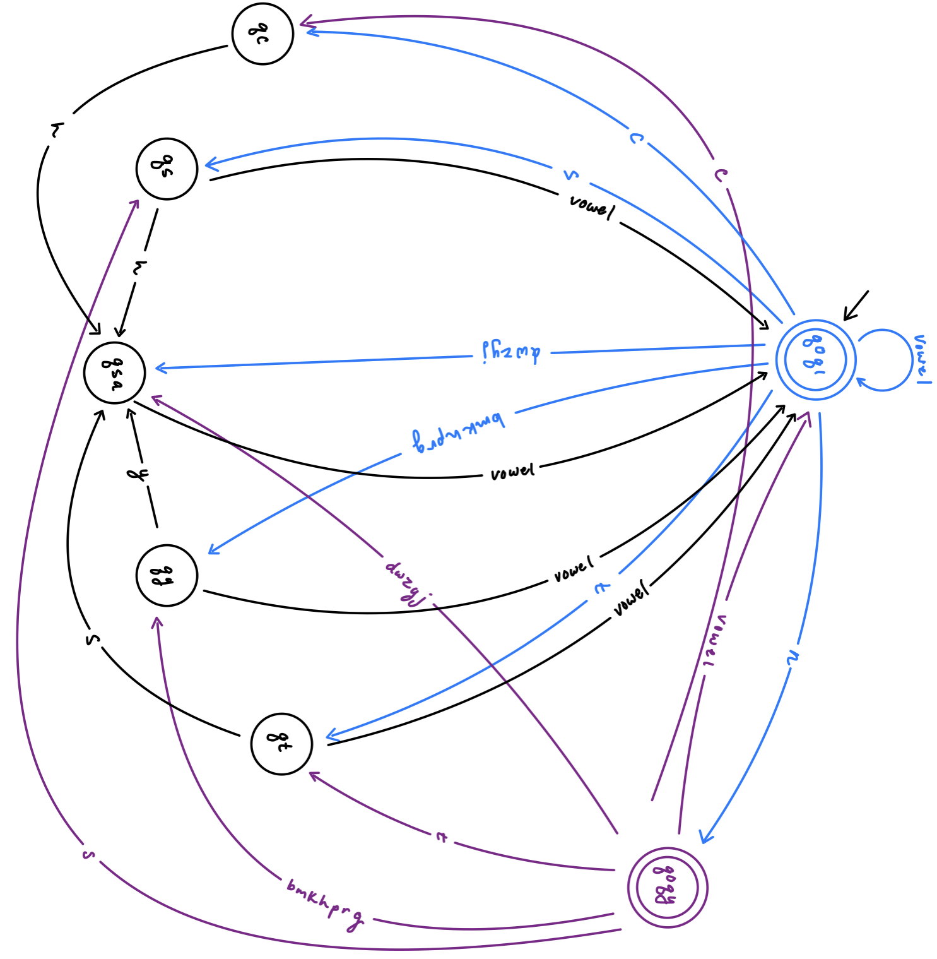

2 – Scanner.cpp

#include<iostream>

#include<fstream>

#include<string>

using namespace std;

/* Look for all **'s and complete them */

//=====================================================

// File scanner.cpp written by: Group Number: 23

//=====================================================

//Done by: Leouel Guanzon and John Foster

//Tables are moved here so functions can access them.

enum tokentype {ERROR, WORD1, WORD2, PERIOD, VERB, VERBNEG, VERBPAST, VERBPASTNEG, IS, WAS, OBJECT, SUBJECT, DESTINATION, PRONOUN, CONNECTOR, EOFM};

string tokenName[16] = {"ERROR", "WORD1", "WORD2", "PERIOD", "VERB", "VERBNEG", "VERBPAST", "VERBPASTNEG", "IS", "WAS", "OBJECT", "SUBJECT", "DESTINATION", "PRONOUN", "CONNECTOR", "EOFM"};

//Array is used for simplicity

string reservedWords[38] = {"masu", "VERB", "masen", "VERBNEG", "mashita", "VERBPAST",

"masendeshita", "VERBPASTNEG", "desu", "IS", "deshita", "WAS",

"o", "OBJECT", "wa", "SUBJECT", "ni", "DESTINATION",

"watashi", "PRONOUN", "anata", "PRONOUN", "kare", "PRONOUN",

"kanojo", "PRONOUN", "sore", "PRONOUN", "mata", "CONNECTOR",

"soshite", "CONNECTOR", "shikashi", "CONNECTOR",

"dakara", "CONNECTOR", "eofm", "EOFM"};

// --------- Two DFAs ---------------------------------

// WORD DFA

// Done by: Leouel Guanzon

// RE:

// (b|g|h|k|m|n|p|r) (y ((a|e|i|o|u|E|I)^+ | (a|e|i|o|u|E|I)^+ n) | (a|e|i|o|u|E|I)^+ | (a|e|i|o|u|E|I)^+ n)

// (a|e|i|o|u|E|I)^+ | (a|e|o|i|u|E|I)^+ n

// (d|j|w|y|z) ( (a|e|i|o|u|E|I)^+ | (a|e|i|o|u|E|I)^+ n)

// s (h((a|e|i|o|u|E|I)^+ | (a|e|i|o|u|E|I)^+ n)) | ((a|e|i|o|u|I|E)^+ | (a|e|i|o|u|I|E)^+ n))

// t (s((a|e|i|o|u|I|E)^+ | (a|e|i|o|u|I|E)^+ n))) | ((a|e|i|o|u|I|E)^+ | (a|e|i|o|u|I|E)^+ n)

// ch ((a|e|i|o|u|I|E)^+ | (a|e|i|o|u|I|E)^+ n)

//Done by: Marco Flores

bool isVowel(char c){

return (c=='a'|| c=='e'|| c=='i'|| c=='o'|| c=='u'|| c=='I'|| c=='E');

}

//Done by: Marco Flores

bool isConsonant1(char c){

return(c=='b'|| c=='g'|| c=='h'|| c=='k'|| c=='m'|| c=='p' || c=='r');

}

//Done by: Marco Flores

bool isConsonant2(char c){

return(c=='d'|| c=='j'|| c=='w'|| c=='y'|| c=='z');

}

//Done by: Leouel Guanzon and Marco Flores

bool word (string s)

{

int state = 0;

int charpos = 0;

/* replace the following todo the word dfa */

while (s[charpos] != '\0')

{

/* States:

* q0q1 = 0

* qsa = 1 = consonant

* qy = 2 = pair

* qs = 3 = s

* qt = 4 = t

* qc = 5 = c

* q0qy = 6 = q1

*/

// q0q1 ==(d|j|w|y|z)==> qsa

if (state == 0 && isConsonant2(s[charpos]))

state = 1;

// q0q1 ==(b|g|h|k|m|p|r)==> qy

else if (state == 0 && isConsonant1(s[charpos]))

state = 2;

// q0q1 ==s==> qs

else if (state == 0 && s[charpos] == 's')

state = 3;

// q0q1 ==t==> qt

else if (state == 0 && s[charpos] == 't')

state = 4;

// q0q1 ==c==> qc

else if (state == 0 && s[charpos] == 'c')

state = 5;

// q0q1 ==n==> q0qy

else if (state == 0 && s[charpos] == 'n')

state = 6;

// (a|e|i|o|u|E|I) (a|e|i|o|u|E|I)^*

// q0q1 ==(a|e|i|o|u|I|E)==> q0q1

// qsa ==(a|e|i|o|u|I|E)==> q0q1

// qy ==(a|e|i|o|u|I|E)==> q0q1

// qs ==(a|e|i|o|u|I|E)==> q0q1

// qt ==(a|e|i|o|u|I|E)==> q0q1

// qc ==(a|e|i|o|u|I|E)==> q0q1

// q0qy ==(a|e|i|o|u|I|E)==> q0q1

else if ((state == 0||state == 1||state == 2||state == 3||state == 4||state == 6) && isVowel(s[charpos]))

state = 0;

// pair followed by 'y'

// qy ==y==> qsa

else if (state == 2 && s[charpos] == 'y')

state = 1;

// from state 3 || 5

// followed by 'h'

// qs ==h==> qsa || qc ==h==> qsa

else if ((state == 3 || state == 5) && s[charpos] == 'h')

state = 1;

// from state 4

// followed by 's'

// qt ==s==> qt

else if (state == 4 && s[charpos] == 's')

state = 1;

// from sate 5

// followed by 'h'

// qc ==h==> qsa

//else if (state == 5 && s[charpos] == 'h')

// state = 1;

// q0qy ==(d|j|w|y|z)==> qsa

else if (state == 6 && isConsonant2(s[charpos]))

state = 1;

// q0qy ==(b|g|h|k|m|p|r)==> qy

else if (state == 6 && isConsonant1(s[charpos]))

state = 2;

// q0qy ==s==> qs

else if (state == 6 && s[charpos] == 's')

state = 3;

// q0qy ==t==> qt

else if (state == 6 && s[charpos] == 't')

state = 4;

// q0qy ==c==> qc

else if (state == 6 && s[charpos] == 'c')

state = 5;

else

return ERROR;

charpos++;

}//end of while

// where did I end up????

if (state == 0)

{

return WORD1; //scanner() function will overwrite to WORD2 if string ends in 'I' or 'E'

}

else if (state == 6) // end in a final state q0 (0) or q0' (6)

{

return WORD1;

}

else

return ERROR;

}

// PERIOD DFA

// Done by: Leouel Guanzon and Marco Flores

bool period (string s)

{

int state = 0;

int charpos = 0;

while(s[charpos] != '\0'){

if(s[charpos] == '.' && s[charpos + 1] == '\0'){

return PERIOD;

}

charpos++;

}

return ERROR;

}

// ------ Three Tables -------------------------------------

// TABLES Done by: Leouel Guanzon and John Foster

// Moved to the top to be use for global scope

/*

// ** Update the tokentype to be WORD1, WORD2, PERIOD, ERROR, EOFM, etc.

enum tokentype {ERROR, WORD1, WORD2, PERIOD, VERB, VERBNEG, VERBPAST, VERBPASTNEG, IS, WAS, OBJECT, SUBJECT, DESTINATION, PRONOUN, CONNECTOR, EOFM};

// ** For the display names of tokens - must be in the same order as the tokentype.

string tokenName[16] = {"ERROR", "WORD1", "WORD2", "PERIOD", "VERB", "VERBNEG", "VERBPAST", "VERBPASTNEG", "IS", "WAS", "OBJECT", "SUBJECT", "DESTINATION", "PRONOUN", "CONNECTOR", "EOFM"};

string reservedWords[38] = {"masu", "VERB", "masen", "VERBNEG", "mashita", "VERBPAST",

"masendeshita", "VERBPASTNEG", "desu", "IS", "deshita", "WAS",

"o", "OBJECT", "wa", "SUBJECT", "ni", "DESTINATION",

"watashi", "PRONOUN", "anata", "PRONOUN", "kare", "PRONOUN",

"kanojo", "PRONOUN", "sore", "PRONOUN", "mata", "CONNECTOR",

"soshite", "CONNECTOR", "shikashi", "CONNECTOR",

"dakara", "CONNECTOR", "eofm", "EOFM"};

*/

// ** Need the reservedwords table to be set up here.

// ** Do not require any file input for this. Hard code the table.

// ** a.out should work without any additional files.

// ------------ Scanner and Driver -----------------------

ifstream fin; // global stream for reading from the input file

// Scanner processes only one word each time it is called

// Gives back the token type and the word itself

// ** Done by: Leouel Guanzon and John Foster

int scanner(tokentype& tt, string& w)

{

// ** Grab the next word from the file via fin

// 1. If it is eofm, return right now.

fin >> w;

if(w == "eofm")

{

return EOFM;

}

/* **

2. Call the token functions (word and period)

one after another (if-then-else).

Generate a lexical error message if both DFAs failed.

Let the tokentype be ERROR in that case.

*/

if(word(w)){

if(w[w.length()-1] == 'I' || w[w.length()-1] == 'E')

{

tt = WORD2;

} else

{

tt = WORD1;

}

/*

3. If it was a word,

check against the reservedwords list.

If not reserved, tokentype is WORD1 or WORD2

decided based on the last character.

*/

/*

4. Return the token type & string (pass by reference)

*/

for(int i = 0; i < 38; i++)

{

if(reservedWords[i] == w)

{

for(int j = 0; j <= 16; j++)

{

if(tokenName[j] == reservedWords[i+1])

{

tt = static_cast<tokentype>(j);

break;

}

}

}

}

}

else if(period(w))

{

tt = PERIOD;

}

else

{

tt = ERROR;

}

if(tt == ERROR)

{

cout << "Lexical error: " << w << " is not a valid token." << endl;

}

return 1;

}//the end of scanner

// The temporary test driver to just call the scanner repeatedly

// This will go away after this assignment

// DO NOT CHANGE THIS!!!!!!

// Done by: Louis

int main()

{

tokentype thetype;

string theword;

string filename;

cout << "Enter the input file name: ";

cin >> filename;

fin.open(filename.c_str());

// the loop continues until eofm is returned.

while (true)

{

scanner(thetype, theword); // call the scanner which sets

// the arguments

if (theword == "eofm") break; // stop now

cout << "Type is: " << tokenName[thetype] << endl;

cout << "Word is: " << theword << endl;

cout << endl;

}

cout << "End of file is encountered." << endl;

fin.close();

}// end

3 – Original Scanner test results

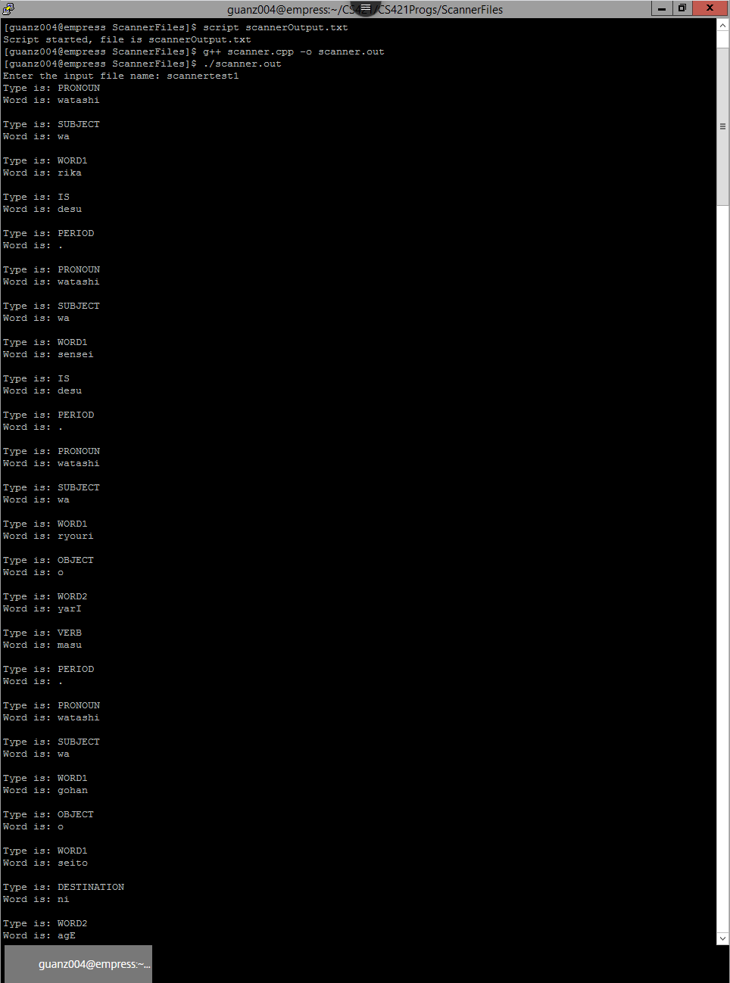

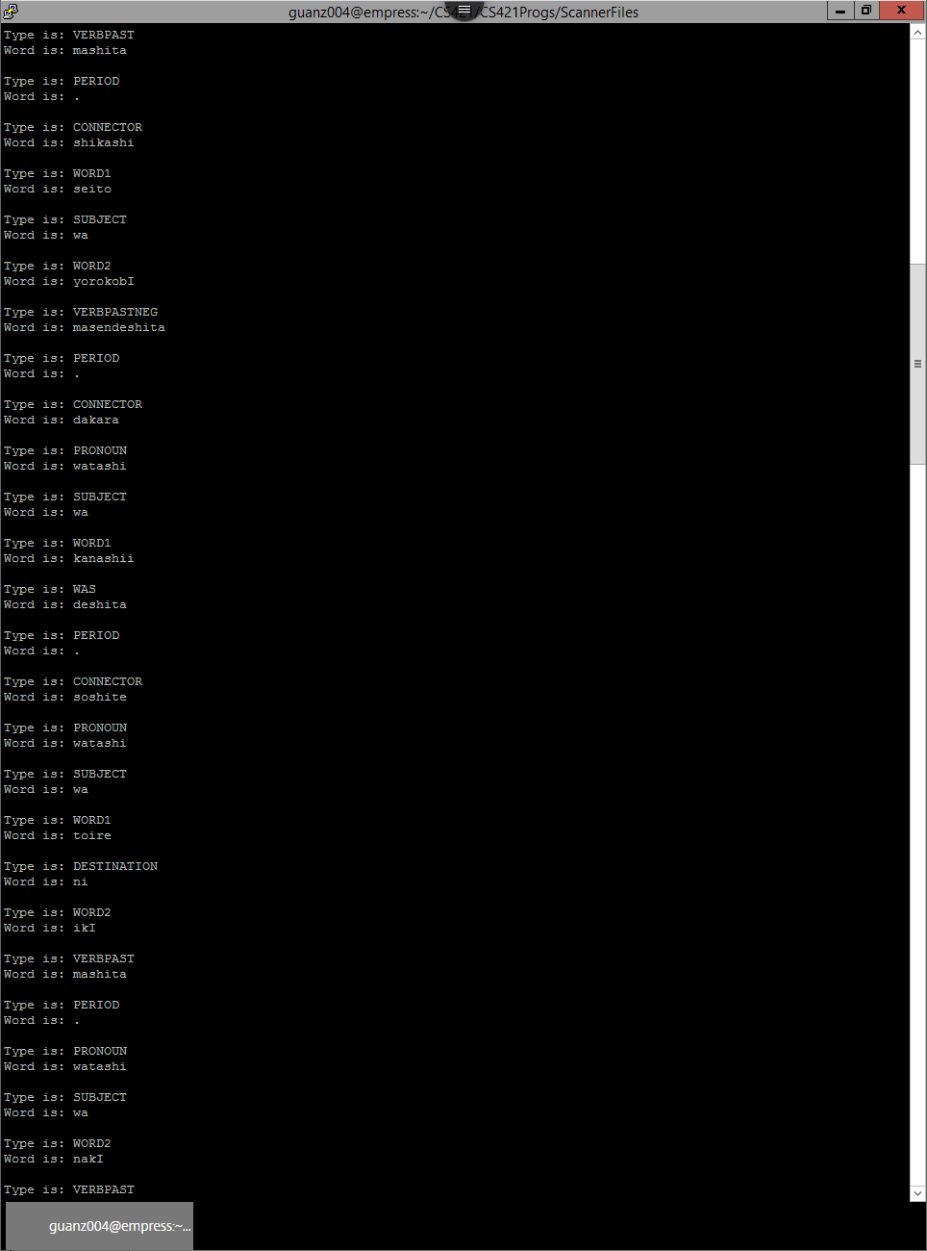

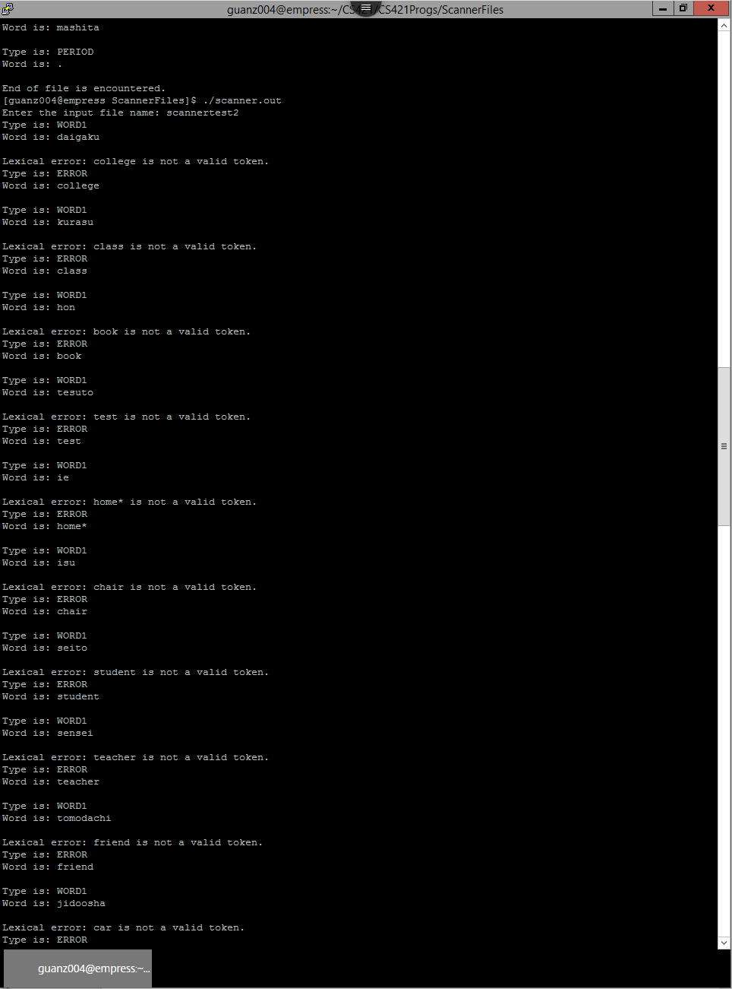

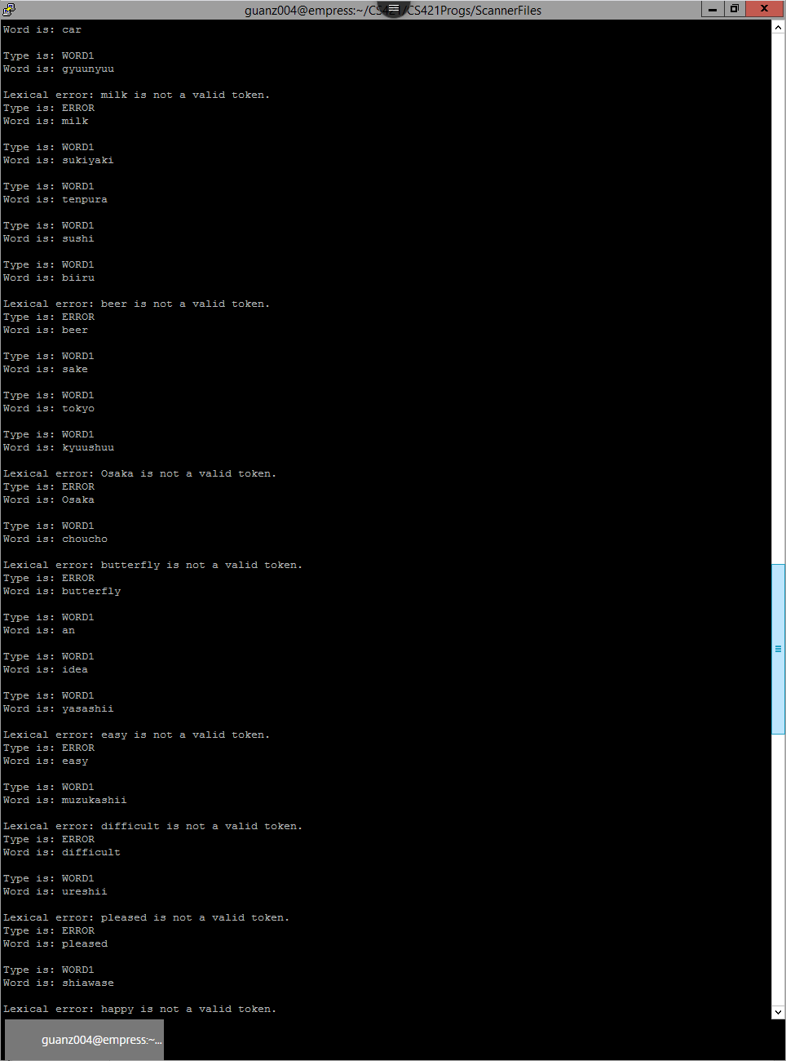

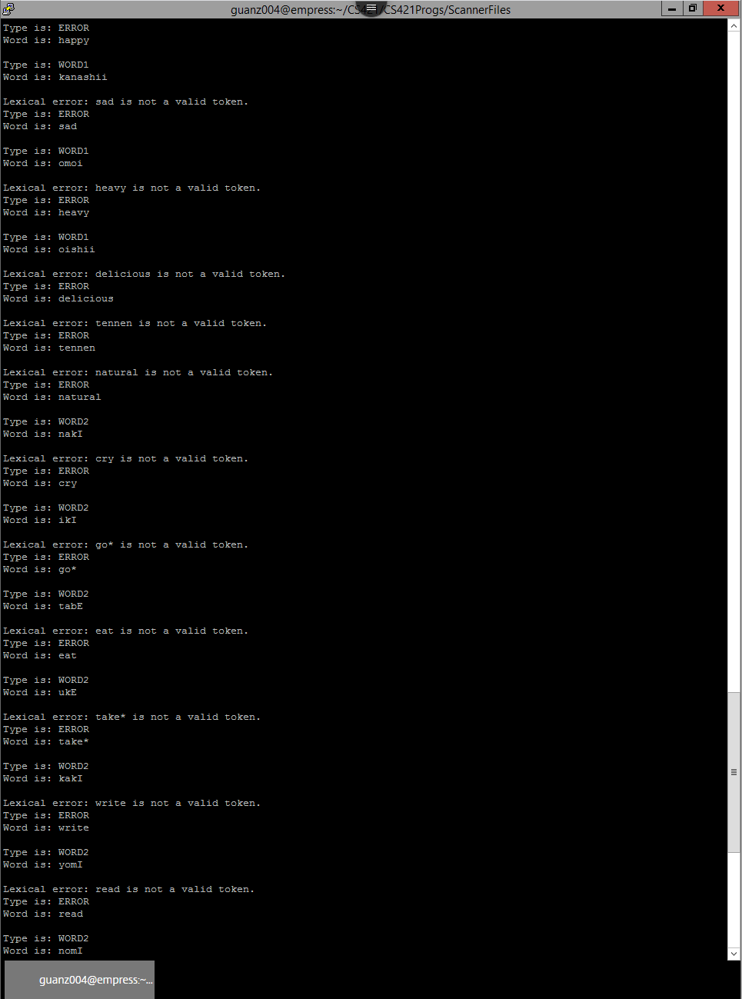

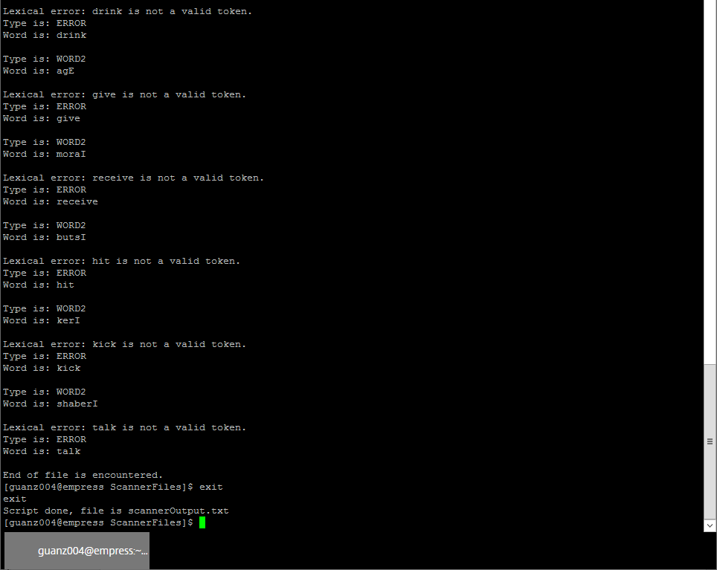4 – Factored Rules

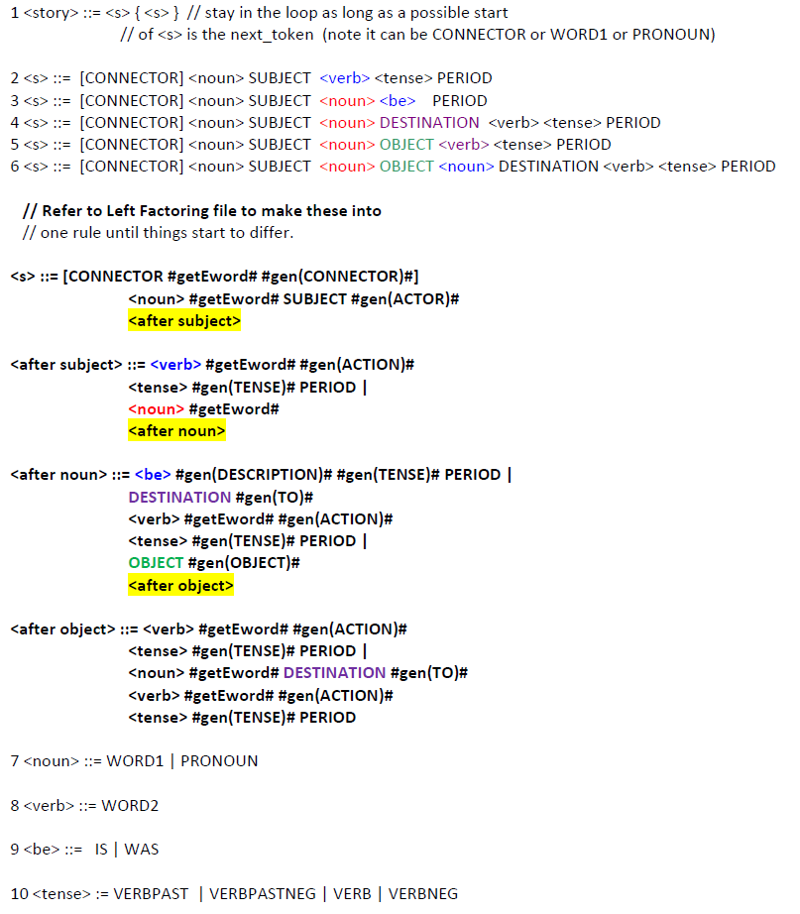

5 – Updated Parser code for Translation